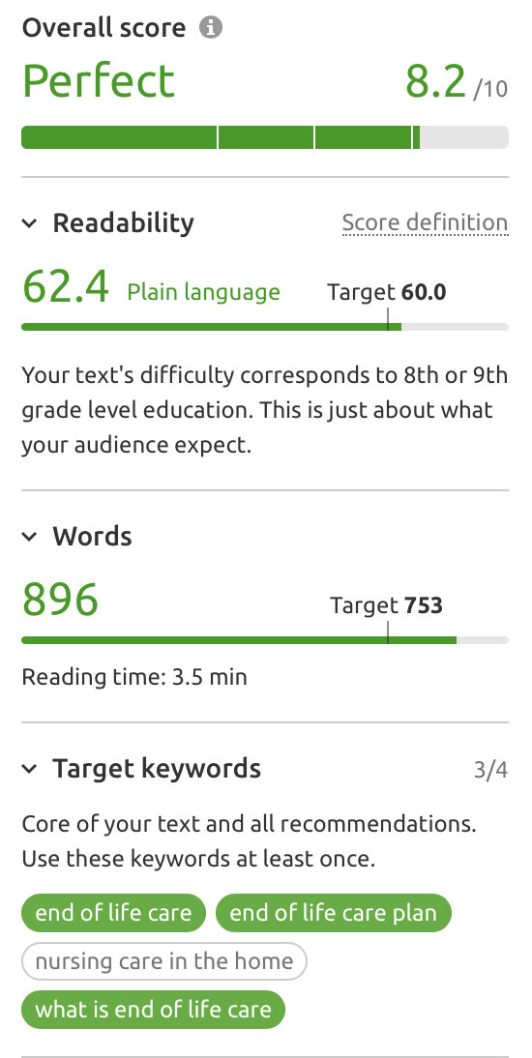 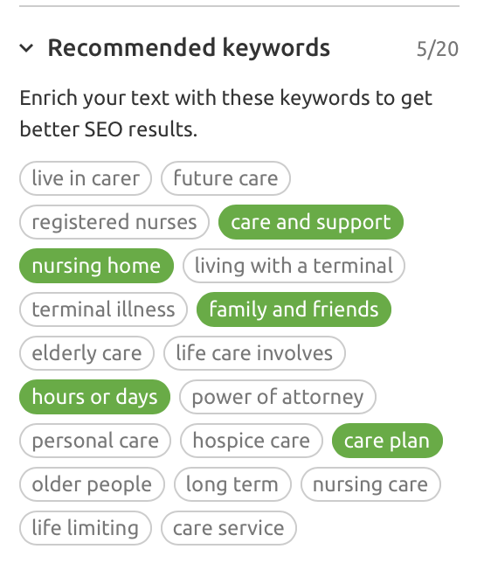

***Note Marie we are missing one keyword “Nursing care in the home”***

*End of life care (6,600 – 84%)*

*End of life care plan (1,000 – 84%)*

*Nursing care in the home (1,000 - 74%)*

*What is end of life care (590 – 90%)*

**END OF LIFE CARE**

As your loved one approaches the final weeks of their life they will receive specialist End of Life Care as part of the Palliative Care they are receiving. This should be delivered with compassion and dignity at all times, especially as their needs change and they may become less aware of what is going on around them.

This care no longer has to take place in a hospice or nursing home. In fact, at this stage moving somewhere new can be unsettling and distressing. There is no medical reason that end of life care cannot be delivered in the comfort of your own home, in familiar surroundings with family and friends.

If your loved one has chosen to spend their final weeks at home, we can support them to make this happen. We can help to put an End of Life Care Plan in place that takes into account your loved one’s wishes and provides the support needed to make the time they have left as meaningful and enjoyable as possible.

There are likely to be many people involved in your loved one’s care, including family, close friends, GP and other healthcare specialists. We can work seamlessly alongside these to make sure your loved one remains comfortable, peaceful and pain free at all times.

The needs and wishes of your loved one will always come first as we care and support not only them, but your whole family too. We understand that this will be an emotional time for your family but hope that by providing support for the day to day tasks and by helping to care for your loved one, we can help to make your final weeks and days together easier.

**WHAT IS END OF LIFE CARE?**

End of life care typically involves the treatment, care and support for people during the last three months of their life, allowing them to pass away in the most comfortable and peaceful way as possible. It is an important part of the Palliative Care which may already have been taking place for some months.

Those receiving Palliative or End of Life Care typically include those who have been diagnosed with an incurable condition such as terminal cancer, those in the later stages of dementia, or those affected by progressive neurological diseases such as motor neurone disease or multiple sclerosis.

The purpose of End of Life Care is to allow people to live as comfortably as possible in the final weeks of their life. It involves managing pain and symptoms as well as supporting emotional and spiritual needs with dignity and respect.

**FIVE PRIORITIES FOR END OF LIFE CARE**

There are five important priorities for End of Life Care in the final weeks of someone’s life.

1. You, and those who are closest to you, should be in involved in decisions about your treatment and care if this is what you want.
2. An individual care plan covering symptom control, pain relief, spiritual support and food and drink, should be agreed with you and delivered with compassion at all times.
3. The healthcare professionals involved in your care should talk honestly and sensitively to you and your family.
4. The needs of your family and those who are important to you should be respected and met whenever possible in accordance with own your wishes.
5. You should be regularly seen by a doctor, and if they believe you may die soon, they must explain this to you and the people closest to you in accordance with your wishes.

**END OF LIFE CARE PLAN**

And End of Life Care plan is a way of documenting your needs and wishes for the final weeks of your life and when you are dying. This can be included in an Advance Care Plan.

The plan should be delivered by those caring for you with compassion, kindness and respect at all times. You should be involved in all important aspects of your care for as long as you are able to, and through a designated person thereafter. Your needs and wishes, and those of those closest to you, should be adhered to whenever possible.

**WHAT TO EXPECT IN THE FINAL MONTHS**

As your loved one comes to the end of their life there are changes that you can expect. In their final three months, you may find that they:

* Sleep more than usual, taking frequent naps during the day
* Have a reduced appetite for both food and drink
* Withdraw from family and friends and stop doing things that they used to enjoy or find comfort in
* Talk less than usual

In the last two weeks of your loved one’s life they are likely to feel tired or drained all the time, so much so that they probably won’t leave their bed. Whatever illness they have, the following changes happen to most people. This can last hours or days. The changes include:

* Different sleep-wake patterns
* Very little appetite or thirst
* Fewer and smaller bowel movements and less urine
* More pain - which can be managed with effective pain relief
* Changes in their blood pressure, breathing and heart rate
* Changes in body temperature which may leave their skin cooler than usual
* Congested breathing
* Periods of confusion, including hallucinations
* Slipping in and out of consciousness

Although distressing for family members, changes in breathing often it isn't painful and can be managed. Pain can also be managed.